Bonus Topic Django:

Check if table is created[¶](https://learnbatta.com/course/django/models/#check-if-table-is-created)

* By default, the django is configured to use sqlite3 database.
* Install the free sqlite db viewer from <https://sqlitebrowser.org/dl/>
* Open the db.sqlite3 file with sqlite db viewer then you will be able see something like below image.

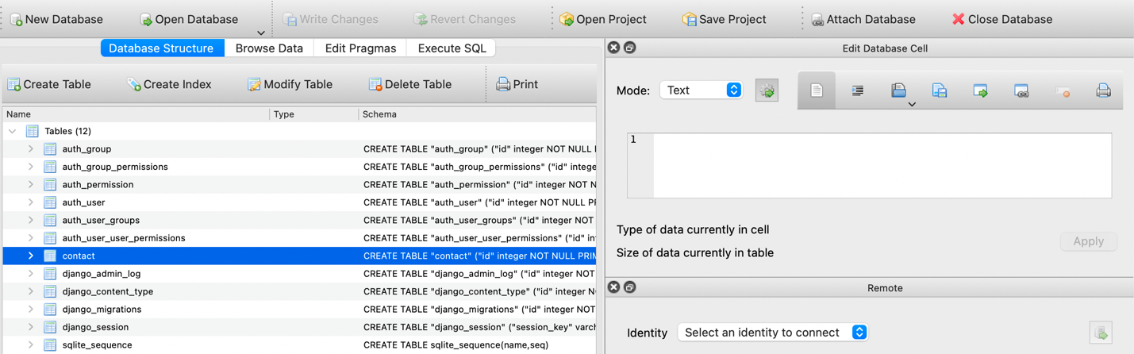

* Can also be checked from django shell
  + Run the command python manage.py shell
  + Import the model from my_app.models import Contact
  + Create a contact Contact.objects.create(first_name="John", last_name="D", email="john@example.com")
  + It will create contact in the database.